Contents

**Actual Cutover** 2

**1.** **Forecast Input and Report Story – Forecast Input page background** 2

**2.** **Daily/Monthly Cutover for Actuals data populating in Forecast Input Page** 2

**3.** **Yearly Cutover for Actuals data populating in Forecast Input Page** 2

**Forecast Cutover** 3

1. Monthly Forecast Cutover Activities 3

**Budget Cutover** 4

**1.** **Forecast Input and Report Story – Forecast Input page background** 4

**2.** **Daily/Monthly Cutover for Budget data populating in Forecast Input Page** 4

**3.** **Yearly Cutover for Budget data populating in Forecast Input Page** 4

# **Actual Cutover**

## **Forecast Input and Report Story – Forecast Input page background**

**The Forecast Input page must** show Actual data at the Account group level instead of 6-digit GL accounts. SAC does not pull up actual data without displaying underlying GL accounts at the group account level. A data action “***Copy Yearly Actual***” to copy underlying GL accounts data into financial statement line/group account level with respectively from Actual version to 6_ACT Version.

## **Daily/Monthly Cutover for Actuals data populating in Forecast Input Page**

**Copy Yearly Actual - Data Action** is required to schedule on a nightly basis if you pull data from S4. If Actuals are loading from a flat file, it’s needed to run this data action upon actuals data file loaded from client desktop. Currently, actuals are not pulling from the underlying S4 source system; hence, they are manually running once actual data has been uploaded.

## **Yearly Cutover for Actuals data populating in Forecast Input Page**

**Copy Yearly Actual - Data Action filter** is required to change the new financial year at the beginning of the planning cycle kickstart.Please see the below print screen where the year is necessary to change. Note – It is a one-time setup for the entire planning year.

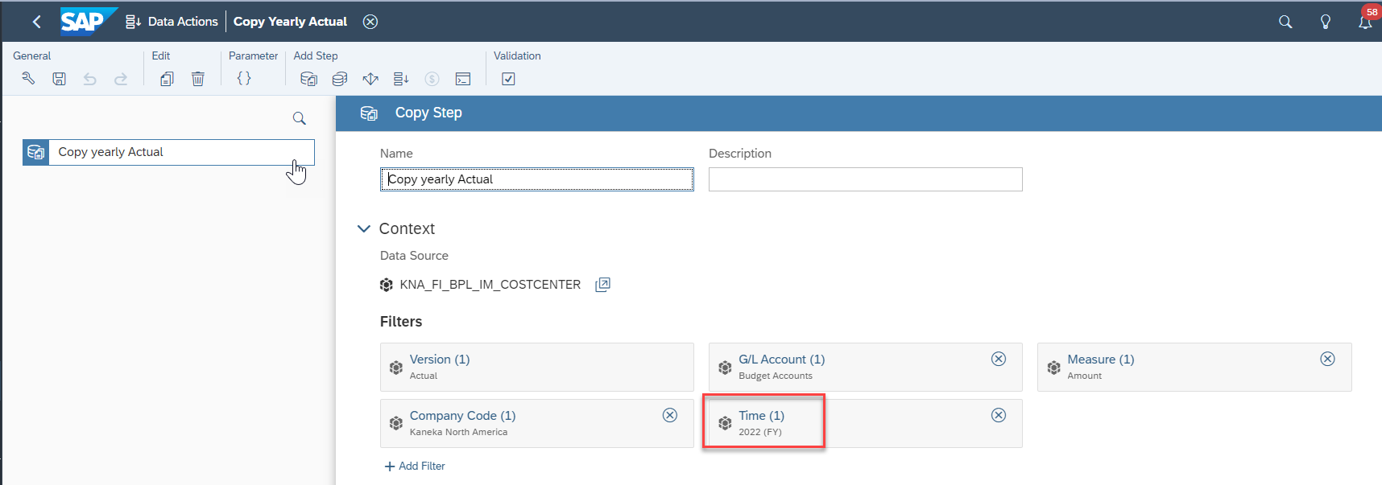

# **Forecast Cutover**

## Monthly Forecast Cutover Activities

Forecast data is entered monthly using Forecast Input and Report Story with respective forecast versions FCT, PJT2, and PJT. Forecast Input Page has been designed to show the prior planning period (PY, BUD, FCT, PJT2, PJT & ACT versions), current planning period, and two future periods. Note this report is works based on the financial planning year period, not system date/calendar month.

SAC Administrator is required to lock versions once the monthly forecast process completion.

Note: If the forecast has required for more than three months, the SAC administrator must go to the designer mode for the Forecast Input page to extend forecasting periods.

1. **CPD Forecast Allocations & Rates – Dev Story**

Forecast Input Column is required to populate only prior year. Please follow the below steps to make it available on every year before planning year initiate.

1. Launch Budget Input for Cost Center Managers – Dev Story
2. Right click on table anywhere to choose Table functions
3. Table Functions 🡪Show/hide 🡪select Table Details

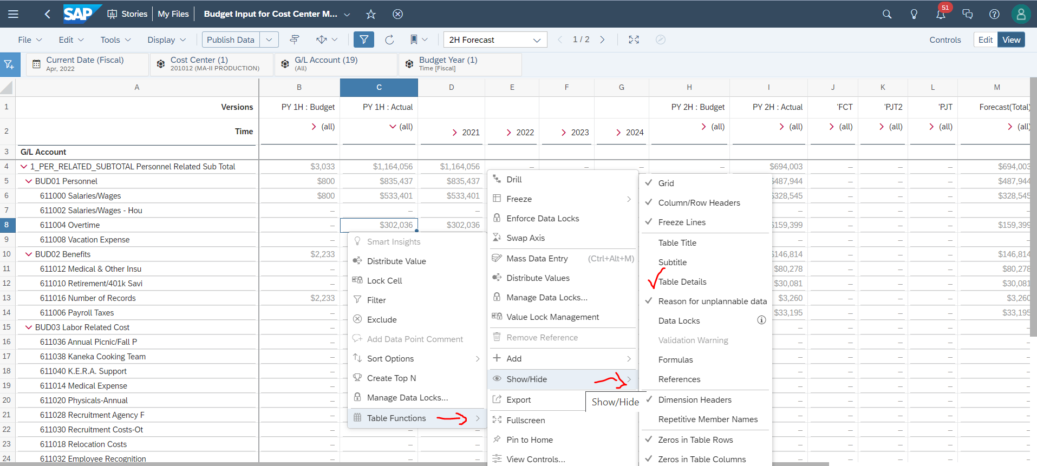

1. You can see now Hidden button and then unhide Prior Period “Forecast Input + 2021.

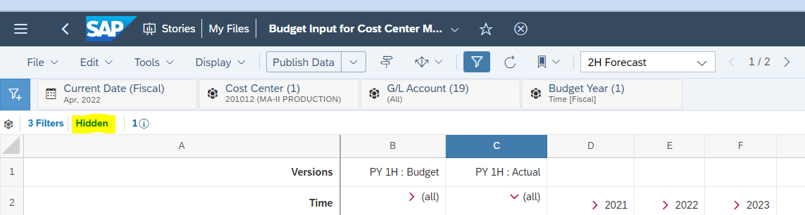

# **Budget Cutover**

## **Forecast Input and Report Story – Forecast Input page background**

**The Forecast Input page must** show Budget data at the Account group level instead of 6-digit GL accounts. SAC does not pull up budget data without displaying underlying GL accounts at the group account level. A data action “***Copy Yearly Budget***” has been created to copy underlying GL accounts data into financial statement line/group account level with respectively from Actual version to 2_BUD Version.

## **Daily/Monthly Cutover for Budget data populating in Forecast Input Page**

**Copy Yearly Budget - Data Action** is required to run manually upon completing yearly budgeting process for current financial planning year.

## **Yearly Cutover for Budget data populating in Forecast Input Page**

**Copy Yearly Budget - Data Action filter** is required to change the new financial year at the beginning of the planning cycle kickstart.Please see the below print screen where the year is necessary to change. Note – It is a one-time setup for the entire planning year.

